November 7-18

Exercise 1- The articles a/an and the in English

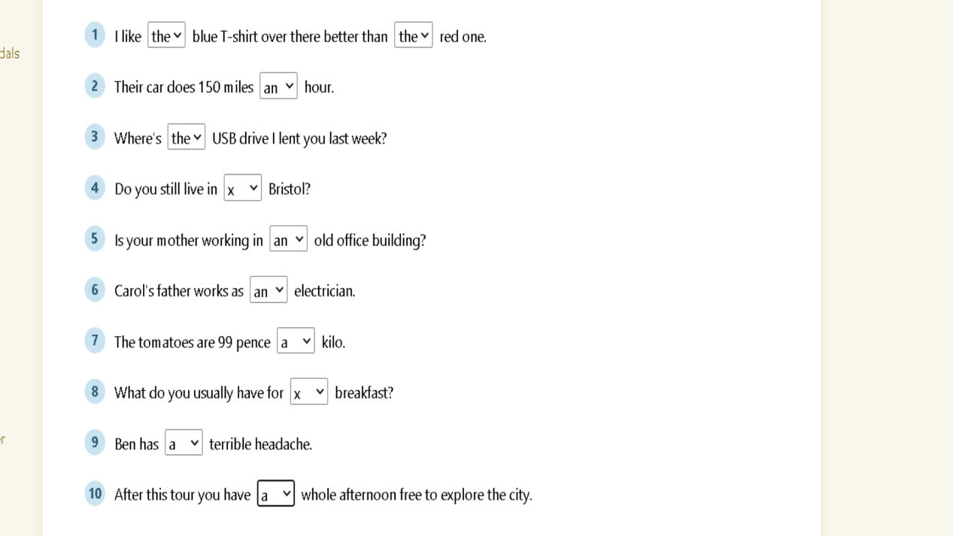

Exercise 2 - The articles a/an and the in English

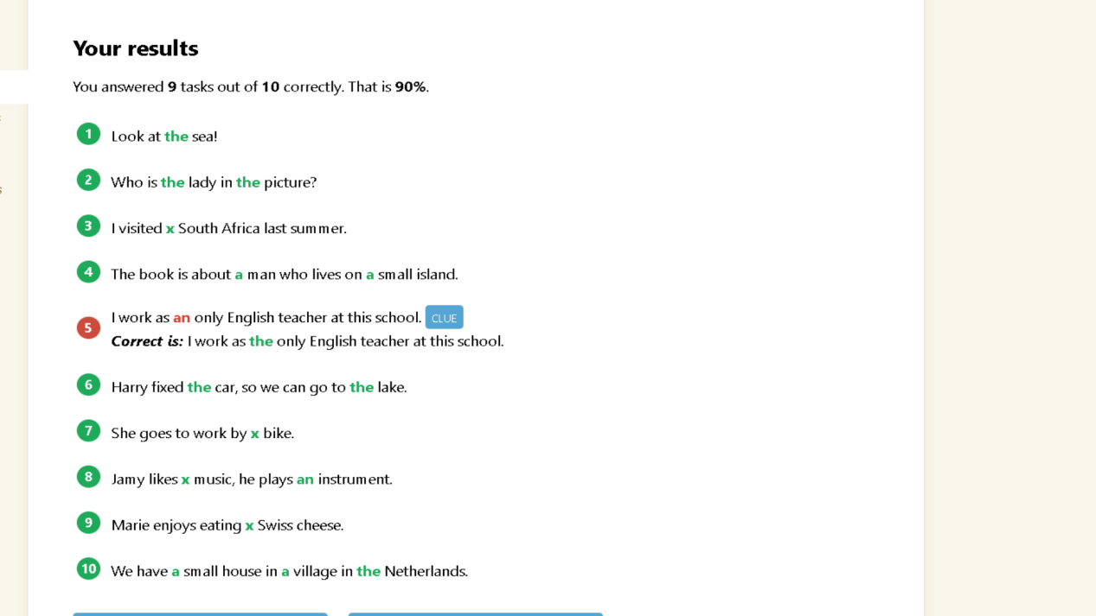

Exercise 3 - a/an or some – English sentences

like

Exercise 1
Fill in the correct indefinite article ‘a’ or ‘an’.

- Would you like a cup of tea?
- I’ll have an orange, a pear, an apple, please.
- This is a great car.
- This is an awful car.
- We’re going to buy a yacht.
- We’re going to buy an other yacht.
- Is there an university in London?
- You’ll have to go the hospital for an X-ray.
- She’s an MP.
- She’s a hard-working MP.
- She’s an honest MP.
- Have you got an euro coin for the slot machine?
- He’s an ex of hers.
- She’s been given an MTV award.
- An owl has made a nest behind our house.
- There’s been an accident with a train.
- An engineer employed by subcontractor filed a complaint.
- A Dutch person is an European citizen.
- It was an honour to meet you.
- It made a real impact on all of us.

Exercise 2. Fill in the blanks with the indefinite article ‘a’, ‘an’, or ‘some’.

- We need to order some more supplies.
- My mother is going to to the hospital tomorrow for an operation.
- Darn, I have a rock in my shoe.
- There is still some coffee left if you want it.
- I’ll get a cup for you.
- Somebody left some trash on our front lawn.
- Please pick up some bananas on your way home.

