Robin Hood

What’s the word?
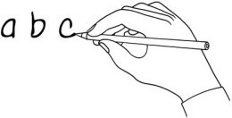
Write the word under the pictures.

archer | feather | forest | criminal | tall | rob
money | rich | poor | sheriff | king | deer

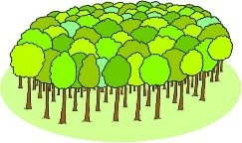 | 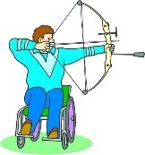 | 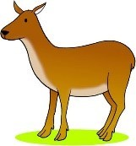 | 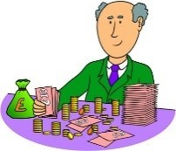 | 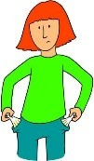 | 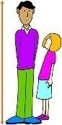
forest | archer | deer | rich | poor | tall
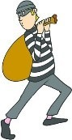 |  | 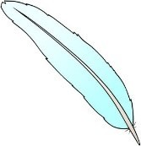 | 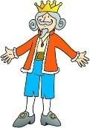 | 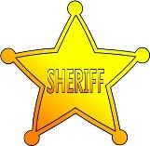 | 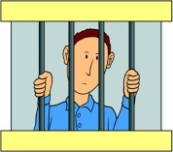
rob | money | feather | king | sheriff | criminal

What’s the order?
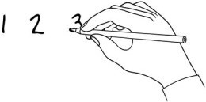
Listen to the story and put the sentences in order.

The Sheriff of Nottingham was Robin Hood’s arch-enemy.
5
3
1
7
5
2
6
4

The stories say that he was extremely intelligent and a skilled archer. People have told stories about Robin Hood for more than 700 years. Robin Hood is a well-loved hero in literature, theatre, TV and films.
He took money from rich people so that he could give it to people who needed it. Nobody knows if he was a real person or an invented character.
The Sheriff of Nottingham tried to catch Robin, but never succeeded.

He lived in Sherwood Forest with a group of outlaws known as his ‘Merry Men’.
www.britishcouncil.org/learnenglishkids
© British Council, 2017 The United Kingdom’s international organisation for educational opportunities and cultural relations. We are registered in England as a charity.

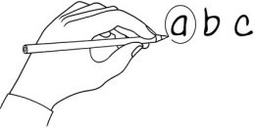
Choose the answer!
Read the sentence. Circle the correct answer.

- People have told stories about Robin Hood for more than years. 600 / 700 / 800
- He always carried a bow and . sword / stick / arrow
- Little John was unusually . tall / short / clever
- Maid was Robin’s true love. Mary / Marian / Margaret
- Most people thought that forests were places. dangerous / safe / exciting
- Robin was famous for ‘robbing from the rich and giving to the ’. sheriff / poor / king
- The Sheriff of Nottingham tried to Robin Hood. help / teach / catch
- Centuries ago people loved to tell about Robin Hood. secrets / facts / stories

Write and draw!
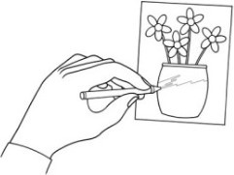
Are there stories about someone in your country who could be a real person or an invented character? Write about them and draw a picture!

..................................................................................................................................

..................................................................................................................................

..................................................................................................................................

..................................................................................................................................

..................................................................................................................................
www.britishcouncil.org/learnenglishkids
© British Council, 2017 The United Kingdom’s international organisation for educational opportunities and cultural relations. We are registered in England as a charity.

